**ECEN 325 - Lab Report**

**Lab Number: 6**

**Lab Title: Diodes**

**Section Number: 503**

**Student’s Name:** [Alex Allahar](mailto:alex.allahar@tamu.edu)

**Student’s UIN: 928009686**

**Date: 10/29/23**

**TA: Mike Ng**

1. **Measurement Plots**
2. **Diode Test Circuit Transient Plot**

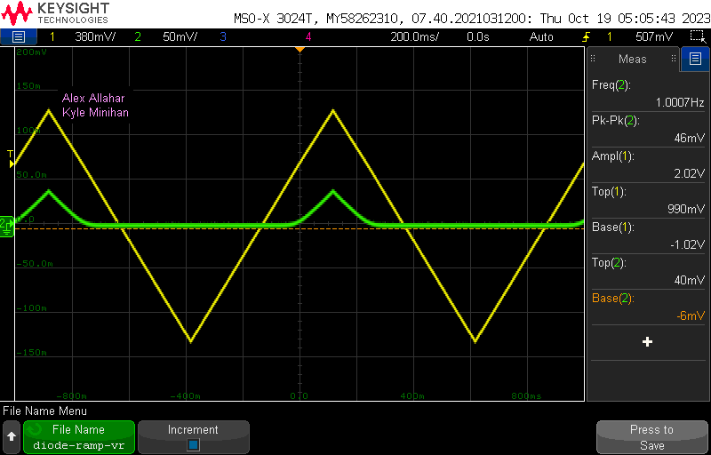

1. **Id vs. Vd Plot**

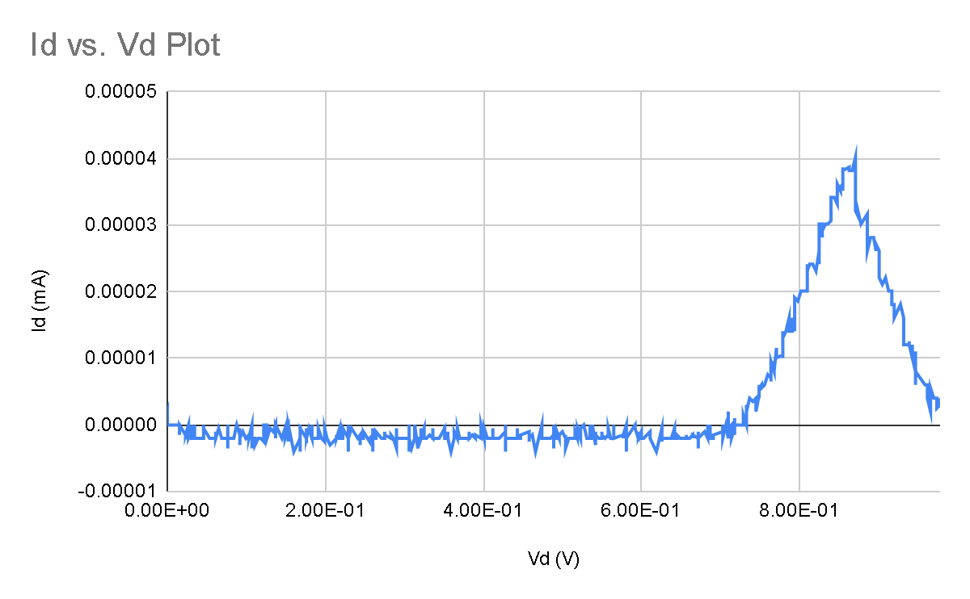

1. **Power Supply Transient Plot**

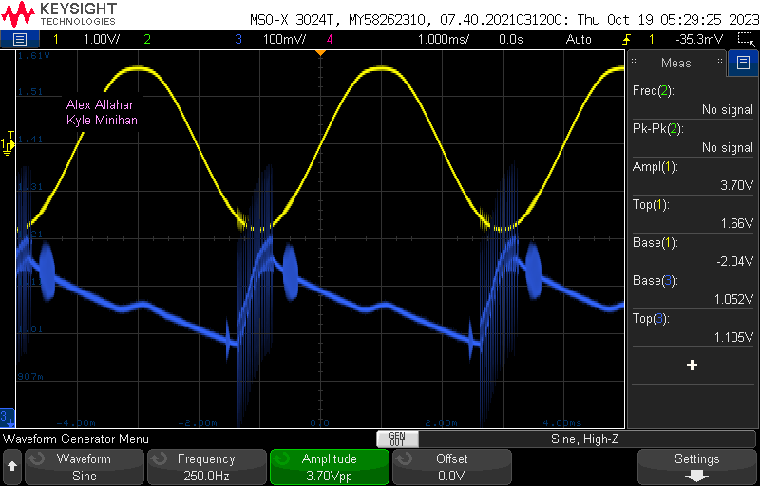

1. **Table**

| Value | Calculated | Simulated | Measured |
| --- | --- | --- | --- |
| C | 20 μF | 20 μF | 20 μF |
| RL | 1 kΩ | 1 kΩ | 1 kΩ |
| Max Ripple | 0.1 | 0.099 V | 0.053 V |
| Current, Peak | N/A | 1 mA | 1.85 mA |
| Vo, Peak | 3.70 V | 3.70 V | 3.70 V |

1. **Compare the results and comment on the differences**

The DC Supply circuit has a minor ripple due to the AC wave generator limited to 5V pk-pk. Thus when applying a +/- 3.7 V input into the inverter it leads to a difference in max ripple. To avoid this an input of 1.85 Vamp would have to be applied to be able to test the whole range of the circuit.